Experiment 9
13-Nov-2024
Measuring of 'g' using Free Fall method

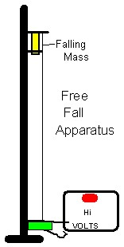

561

